# **Quick Sort**

Quick sort works on the idea that the element is already in a sorted position, if all the elements to its left are smaller and all the elements to its right are larger

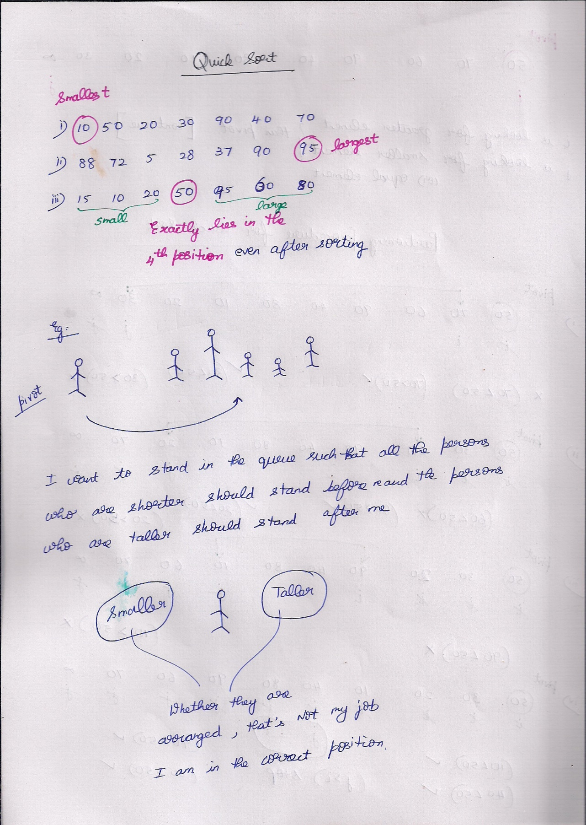

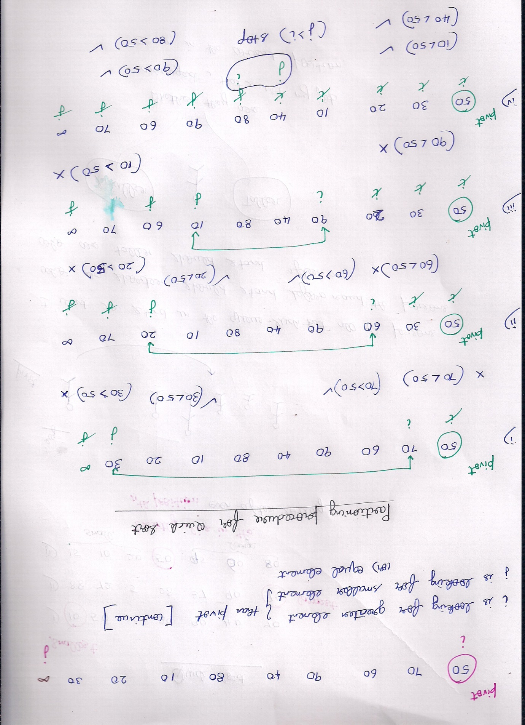  
if i is smaller than pivot 🡪 continue  
If j is larger than pivot 🡪 continue



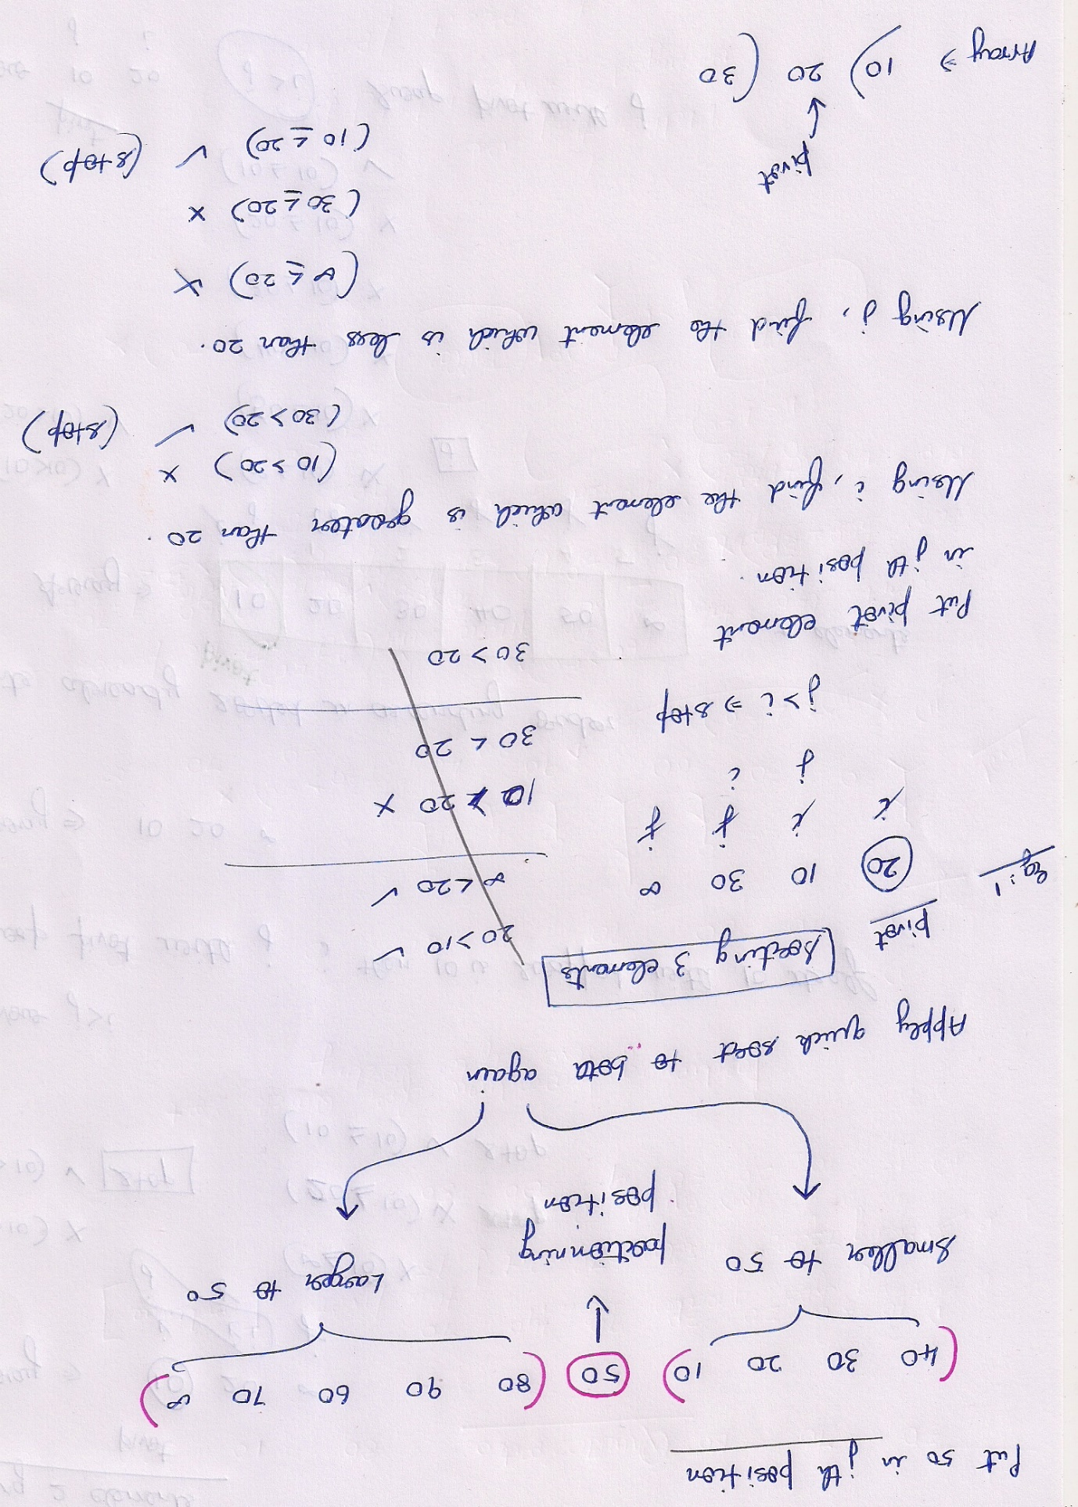

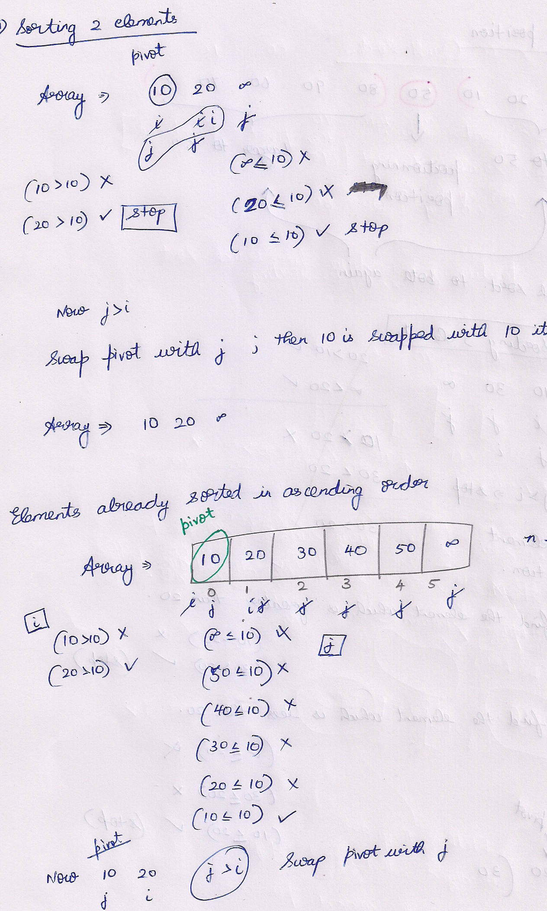

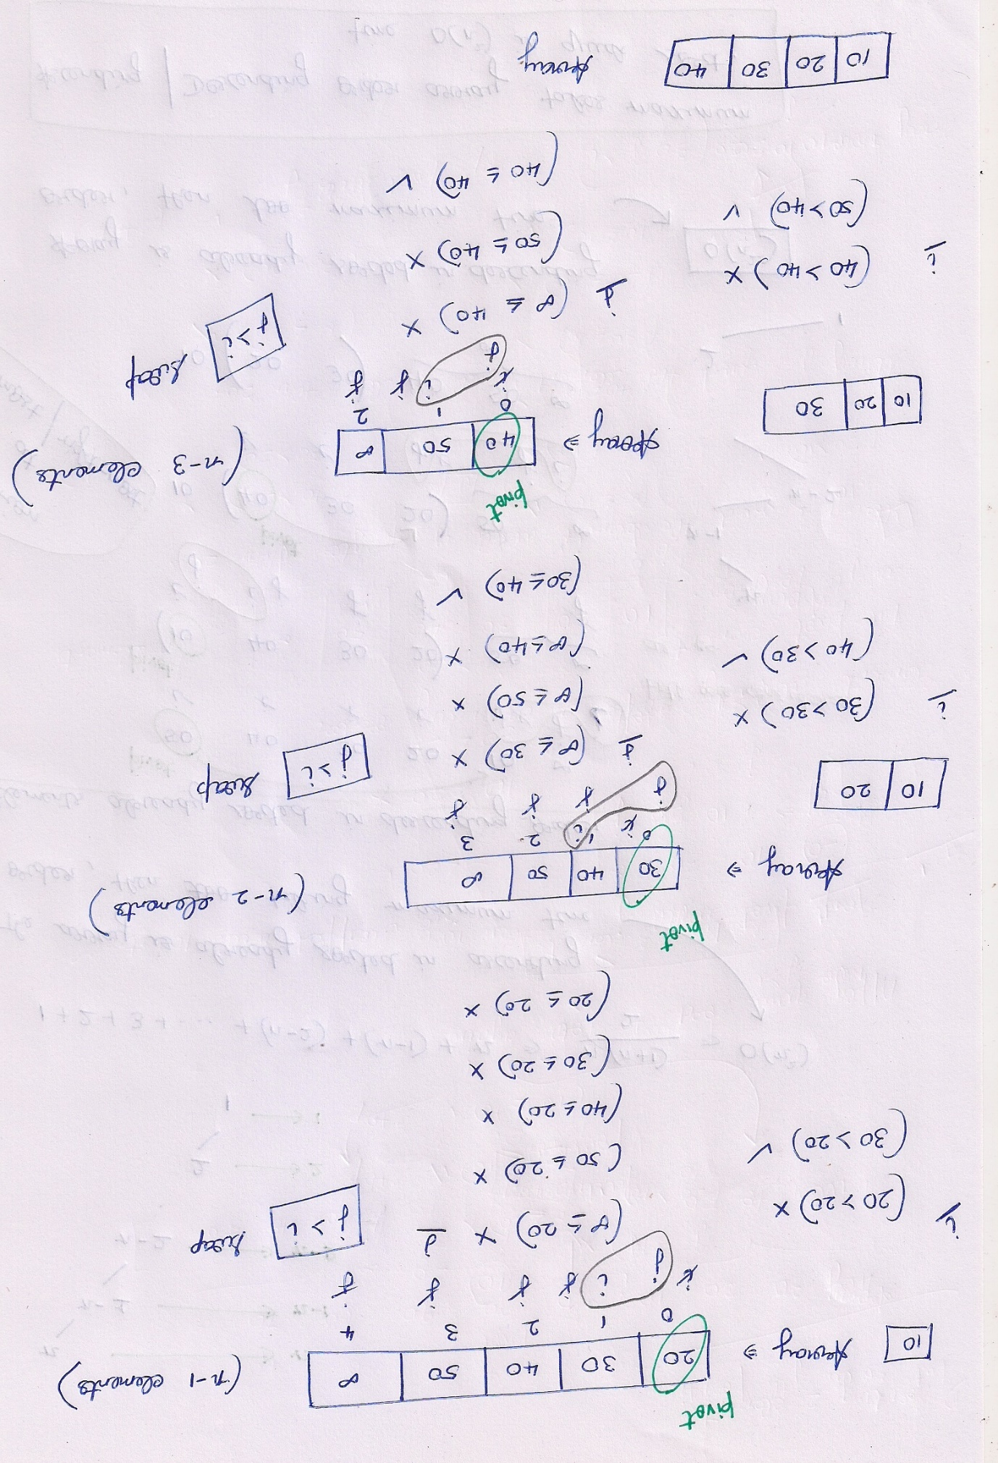

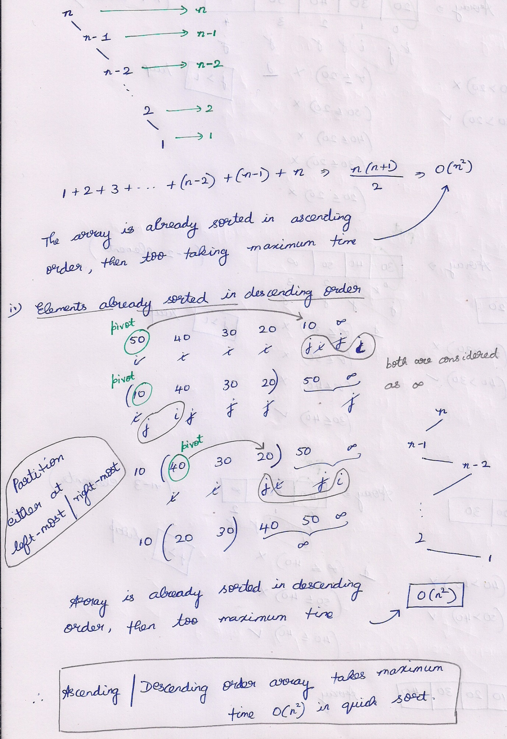

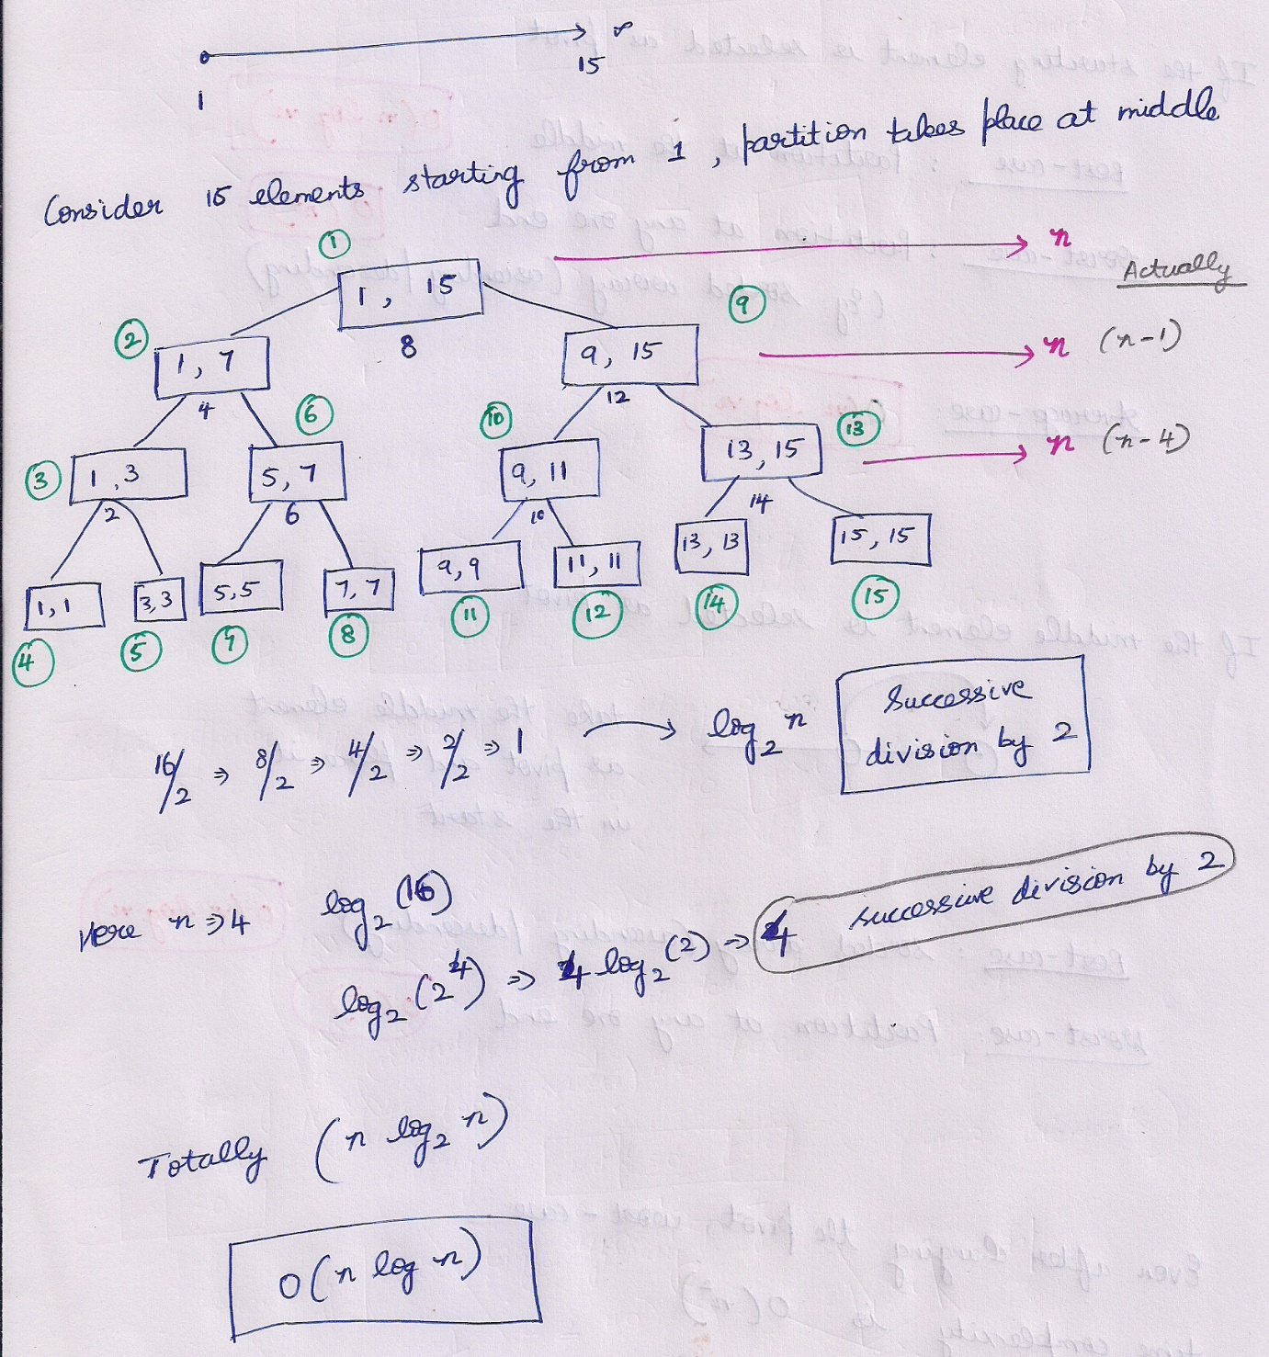

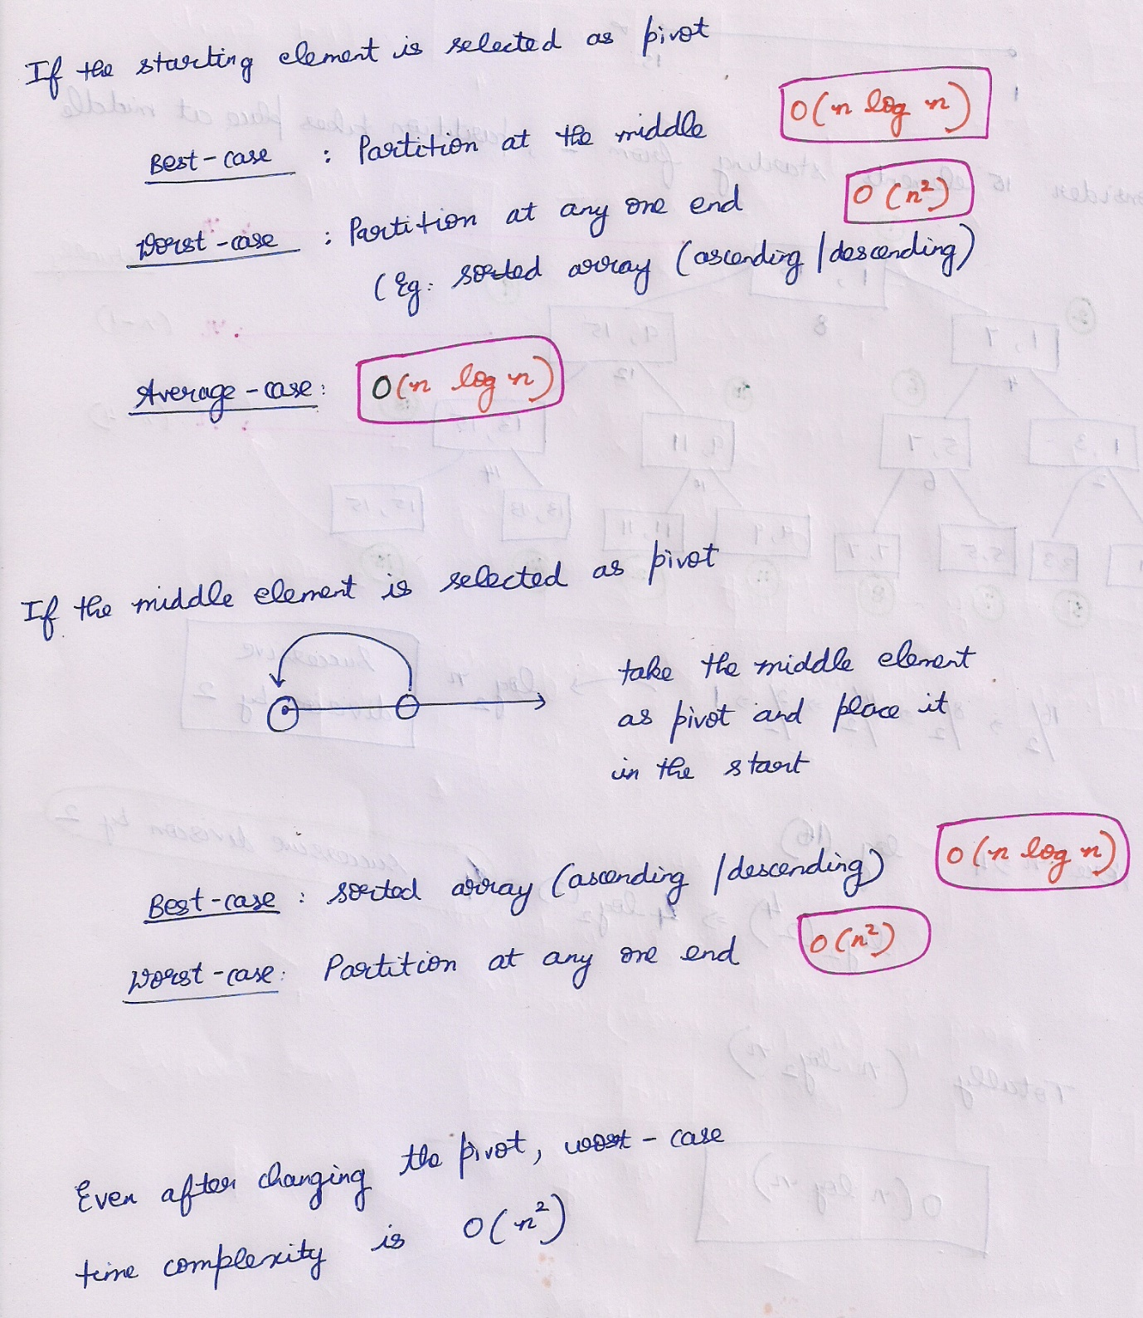

# **Las Vegas**

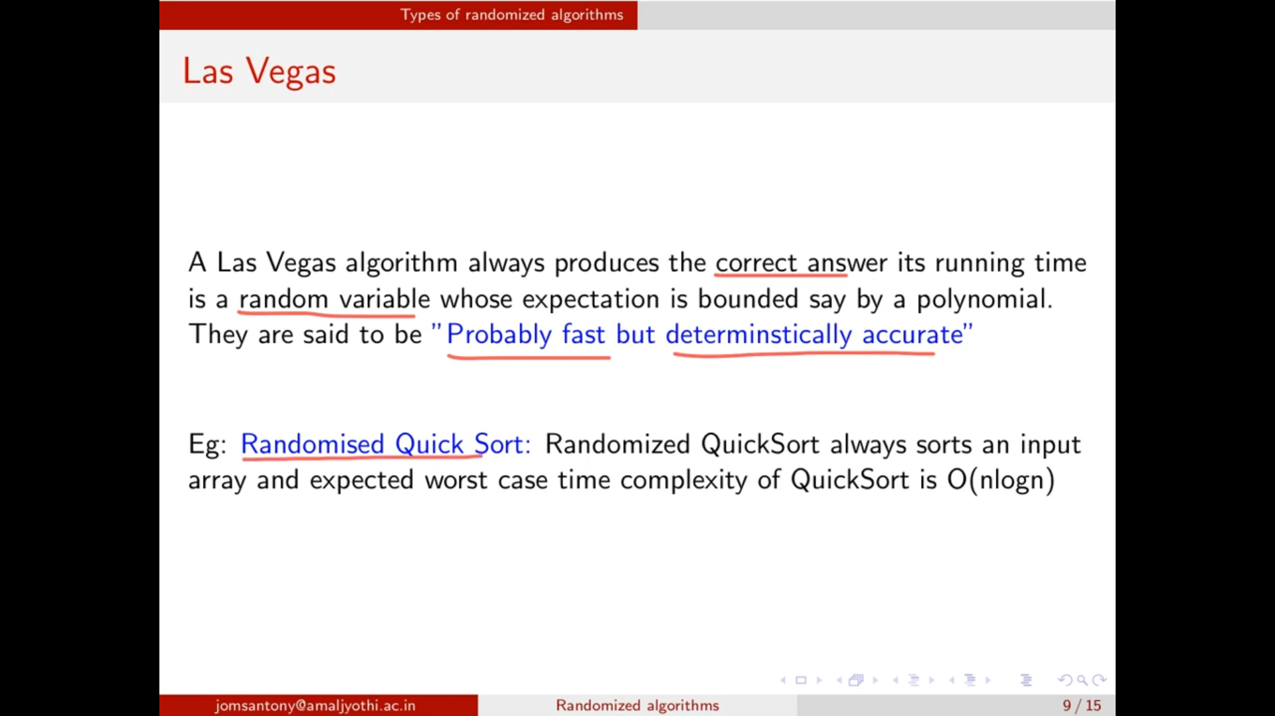

## **Randomized Quick Sort**

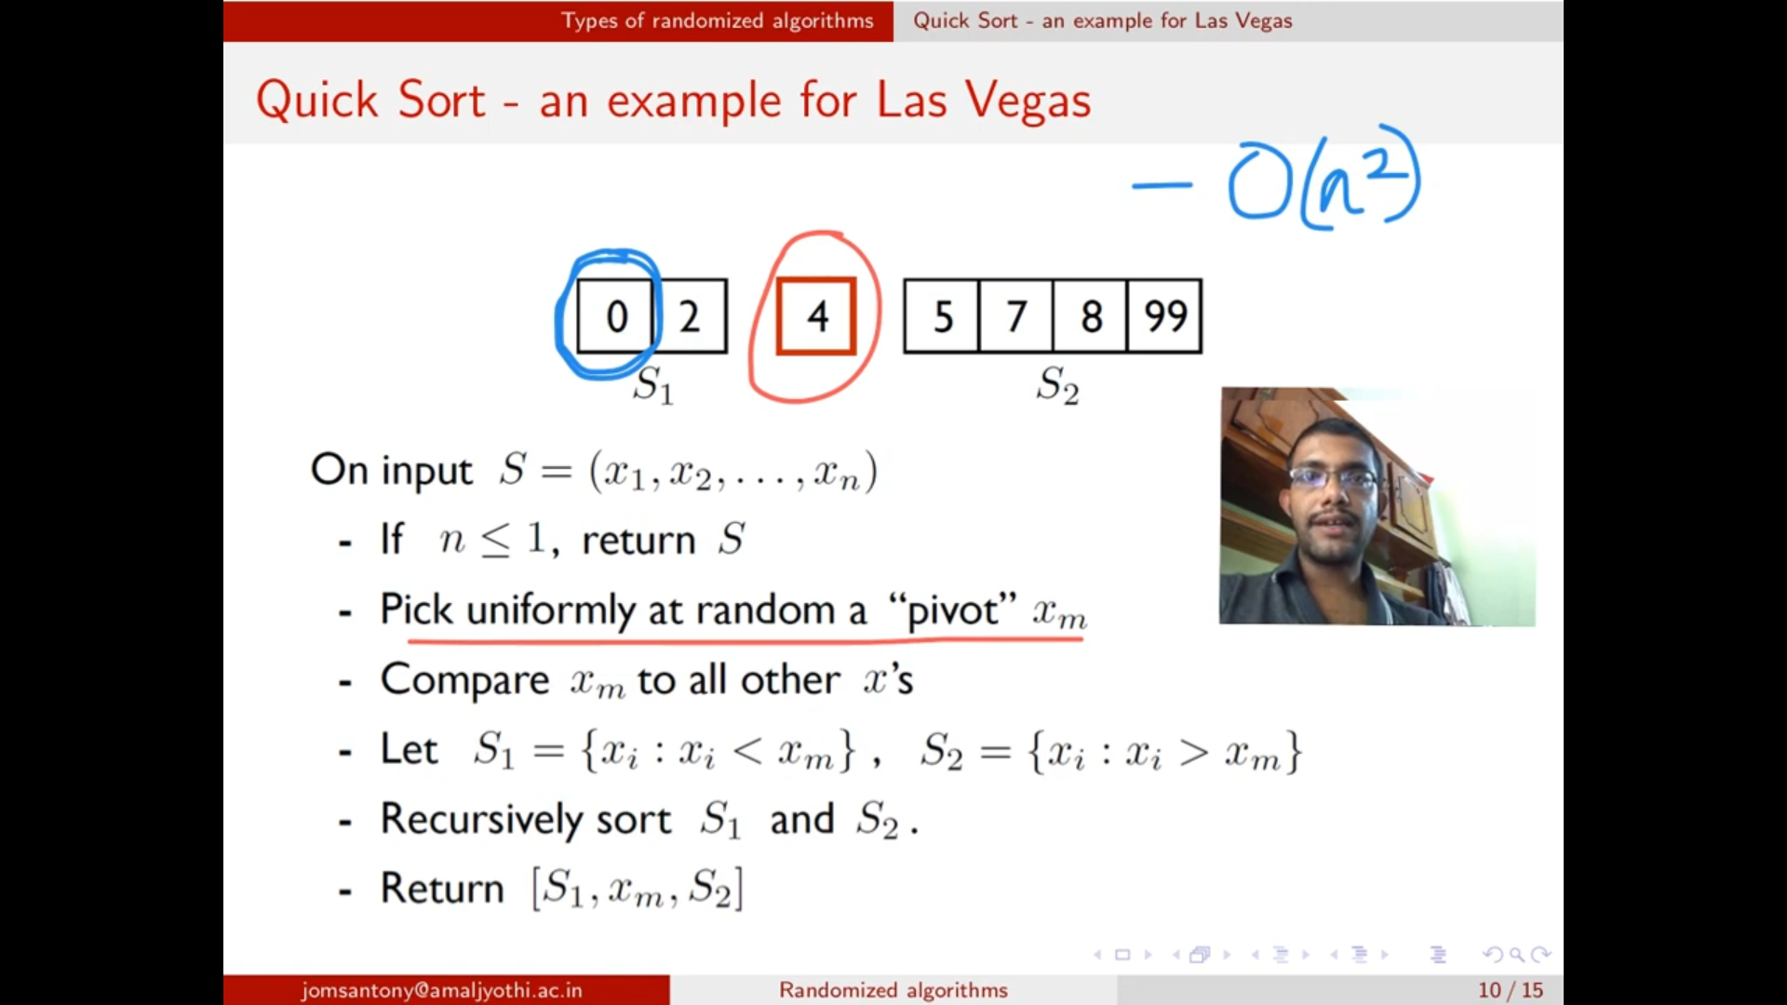

Pivot is selected randomly.

Normal quick sort 🡪 O(n^2)  
Randomized quick sort 🡪 O(n logn)

## **Searching Repeated elements**

i and j 🡪 random numbers must be generated within the array index. So only using   
**i = Random() mod n+1**   
**j = Random() mod n+1**

Indices should be different. And the elements matching.

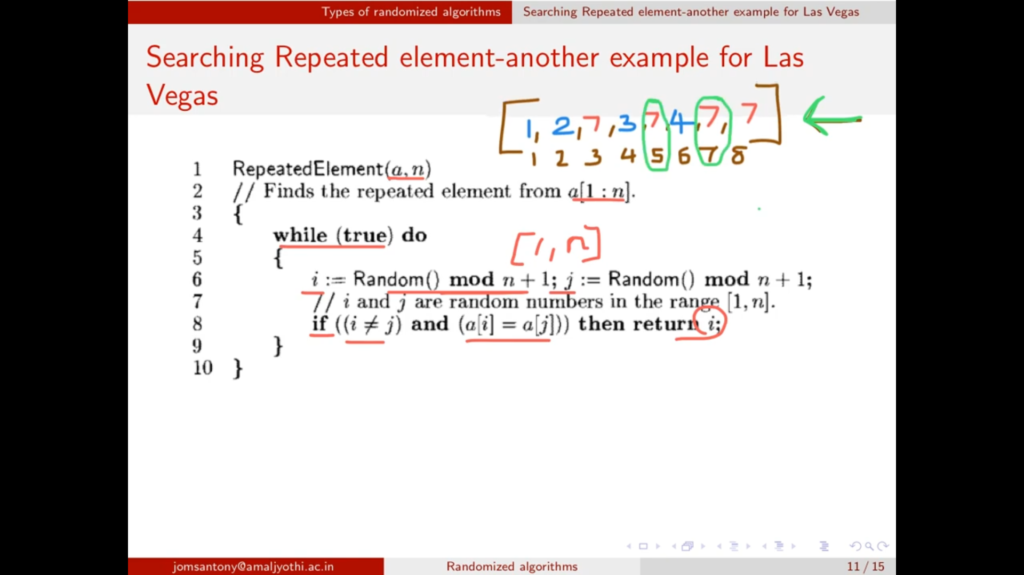

i = 5th index will be returned.

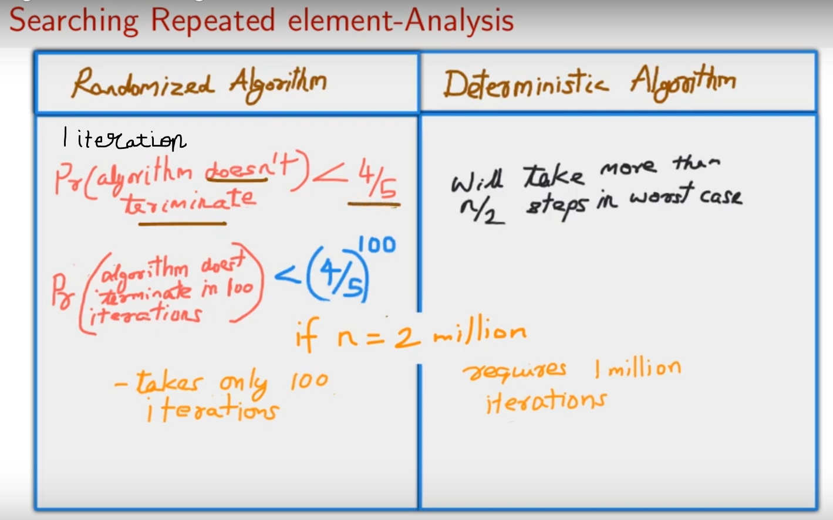

# **Monte Carlo Algorithm**

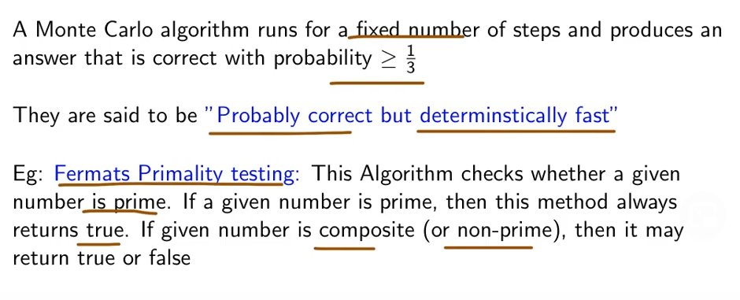

These algorithms are very use-full for the applications which doesn’t mind an occasional incorrect answer.

